**Safe Routes to School Street Light Banner Design Contest**

**Project Overview:**

Cupertino Safe Routes to School is looking for talented high school students to showcase their artistic abilities and design new street light banners for the City of Cupertino. These banners will encourage and promote alternative transportation use throughout the City. The designs that are chosen will be placed on street light banners for our entire community to appreciate. Banners will be placed on street lights along De Anza Blvd, Stevens Creek Blvd, and Stelling Rd. This is an opportunity to be involved with a community focused effort to bring art to public spaces.

**Design Overview:**

We are looking for banner designs that reflect the positive emotions associated with the themes of:

● The joy of walking and biking

● The environmental benefits of walking and biking

● Walk & Roll

● How biking improves student cognitive development and mental health

● Active and sustainable transportation

● The benefits of carpooling

● The future of student transportation

All designs must clearly include the words, ‘Safe Routes to School’. Students may collaborate as a group or submit work individually. There is no cap on the number of submissions that a group or individual can produce. Every submitted design must follow the complete application process. Artwork must be original. Your artwork submission must be your own original concept and not a copy of anyone else’s material. If your image infringes upon another’s copyrighted material, it will be disqualified. You may be required to show proof that your entry is your original artwork.

*Dimensions:* Students may create a digital design or draw their design on an 8.5” x 11” piece of paper and scan it to submit as a PDF. The final design must be able to scale up to 30” x 84”.

**Selection Criteria and Process:**

● Submissions must include a title and a brief paragraph describing the design and how it aligns with one of our themes

● Artwork must be 2D

● Artwork must be an original design from the entrant(s)

● Artwork must be submitted with the signed entry and authorization form on the back

of this form

● Artwork must be simple and clear enough for drivers to see from a distance while

traveling fast

● Artwork must fit one of the multiple themes and meet the above criteria or else it will not be considered

Proposals may either be submitted via email to [saferoutes@cupertino.org](mailto:saferoutes@cupertino.org) or uploaded to the dropbox linked on the Cupertino Safe Routes to School website homepage. No submissions will be accepted after Friday, May 21. The authorization to use artwork must be signed. Submissions will be divided by school and at least one winner will be chosen from each school. Selections will be made by the Cupertino Safe Routes to School team based on artistic merit and completeness of the application. Late submissions or those that do not follow the criteria will not be considered. Winners will be announced in late May and banner installations will begin in the fall.

**Project Entry Form:**

First Name: ________________________________ Last Name: _____________________________

Age: __________ School: _______________________________ Grade: ___________________

Address: ______________________________________ City: ______________________________

Phone: ______________________________ Email: _______________________________________

Signature: ___________________________________________________________________________

Title of Submission: ___________________________________________________________

**Please attach a brief paragraph desribing your design and how it aligns with one of our themes.**

**Attach your design(s) on the final page of the application.**

**AUTHORIZATION TO USE ARTWORK:**

I represent that this is my original artwork and I am the author and contributor of all of the art in this submission. I understand that, by entering this contest, I waive any and all rights to compensation for the artwork submitted. I hereby grant to the City of Cupertino and their authorized agents and employees the right to use my artwork, the rights in all copyright in this artwork, and the right to enhance and modify the artwork for the Safe Routes 2 School “Banner Design” project, or any other publicity deemed necessary and appropriate for the event as well as any other materials produced or provided by the City of Cupertino. I understand that my submission will not be returned. I understand that my artwork, if applied to a streetlight pole banner, may be altered from its original design or removed in the future for any reason, and I further understand that the City of Cupertino shall have any duty, obligation, or liability to restore the artwork if it is defaced or painted over. I also authorize the City of Cupertino to use my name in conjunction with the artwork whenever it is used, including during any publicity deemed necessary and appropriate for these programs. I understand no monetary or other compensation will be offered to the winners or anyone entering this contest, and that I will have no financial gain or benefit from the production, distribution, and/or sale of artwork. I hereby release the City of Cupertino from any claims or demands associated with the artwork including, without limitation, the right of privacy or publicity.

Contestant Signature: _________________________________________________________________

**IF UNDER THE AGE OF 18:** I am the parent or legal guardian of the Contestant. I have read the authorization to use artwork and understand its terms. I represent and warrant that I have the legal authority to enter into this authorization for use of artwork.

Parent or Guardian Signature: _________________________________________________________

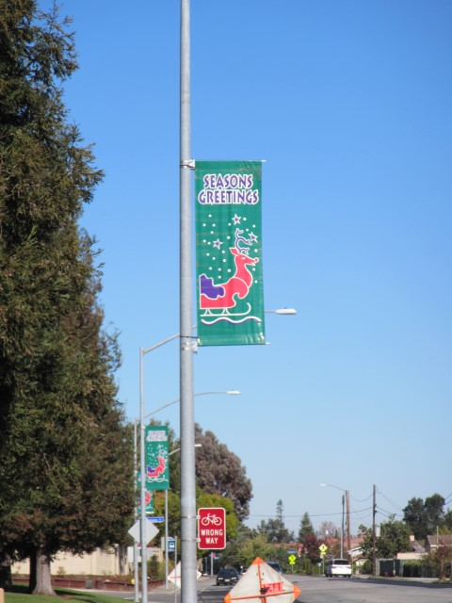

Examples of Street Light Banners on Stelling Rd. and Stevens Creek Blvd.

